Rs.36,750
Winters In Dubai

DAY-1
HOTELCHECK IN FOR
4 NIGHTS

SIGHTSEEING
Arabian Park Hotelor Similar
Dhow Cruise with dinner

DAY-2
HOTEL
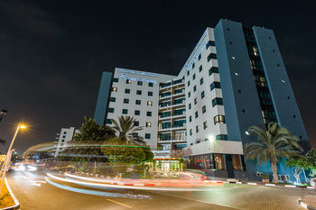
SIGHTSEEING
Arabian Park Hotelor Similar
Desert Safari with BBQ dinner

DAY-3
HOTEL
SIGHTSEEING
Arabian Park Hotelor Similar
Dubai City Tour

DAY-4
HOTEL
SIGHTSEEING
Arabian Park Hotelor Similar
Burj Khalifa
Dubai Aquarium

DAY-5
HOTELCHECK OUT
Arabian Park Hotelor Similar
Dubai
From: DAY-1 to DAY-5

